If energy is defined as the ability to do work, then energy and work must have the same units. Thus, the SI unit of the energy is the Joule (recall 1J=1Nm=1kgms2). Energy, however, is one quantity where there are many other units in common use in scientific literature including electron-Volts (eV), kilowatt-hours (kW∙hr), calories, and Calories. In this course, we will be using Joules and electron-Volts exclusively. We are including these other units for your reference.

# Electron-Volts

A common quantity in chemistry is the electron-Volt or eV. One electron-Volt is the amount of energy gained by an electron as it travels between the two ends of a 1 Volt battery (a concept that will be discussed in more detail when you study electricity). Numerically, 1eV = 1.602×10-19J. The reason this unit is common in chemistry is that the energies of atomic bonds are typically about 1eV as shown in the table below

|  |  |  |
| --- | --- | --- |
| Bond | Bond-dissociation energy at 298K (eV/Bond) | Comment |
| C-C | 3.60-3.69 | Strong, but weaker than C–H bonds |
| Cl-Cl | 2.51 | Indicated by the yellowish colour of this gas |
| H-H | 4.52 | Strong, nonpolarizable bond  Cleaved only by metals and by strong oxidants |
| O-H | 4.77 | Slightly stronger than C–H bonds |
| OH-H | 2.78 | Far weaker than C–H bonds |
| C-O | 11.16 | Far stronger than C–H bonds |
| O-CO | 5.51 | Slightly stronger than C–H bonds |
| O=O | 5.15 | Stronger than single bonds  Weaker than many other double bonds |
| N=N | 9.79 | One of the strongest bonds  Large activation energy in production of ammonia |
| H3C-H | 4.550 | One of the strongest aliphatic C–H bonds |

# Kilowatt Hours

When you buy electricity from the power company, the bill says how many kilowatt hours you have purchased. A Watt is a unit of a quantity called *power* and 1 Watt is equal to 1 Joule/second: 1W = 1 J/s. Thus, a kilowatt hour is:

$$\left(1 kW*hr \right)\left(\frac{1000 W}{kW}\right)\left(\frac{1 J/s}{W}\right)\left(\frac{3600 s}{hr}\right)=3.6106 J=3.6 MJs$$

The calorie is an imperial unit of energy that is still in common use in the nutritional sciences in the United States. One calorie (lowercase c) is the amount of energy needed to raise 1g of water 1oC or 1 cal = 4.814J. On food labels, you will see energy listed in Calories (capital C). One Calorie is equal to 1kilocalorie; in other words, 1 Cal = 1000 cal. Thus, one 1 Cal = 4814 J. In other countries, you will see food labels in both Calories and Joules like the one shown in Figure **1**.

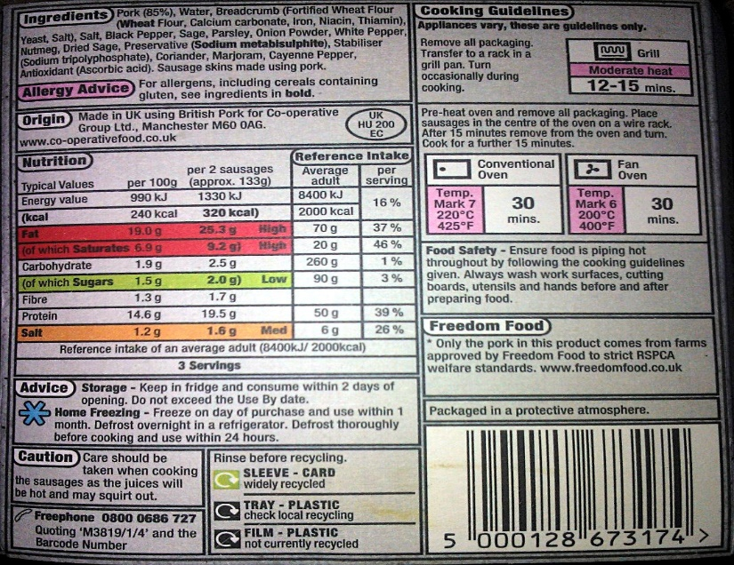

*Figure* ***1****: A food label from the UK showing the energy of the food in both Joules and kcal (or Calories).*